Austin McCalley

Dr. Jennifer Parham-Mocello

Computer Science 160-020

3 October 2019

Assignment 2

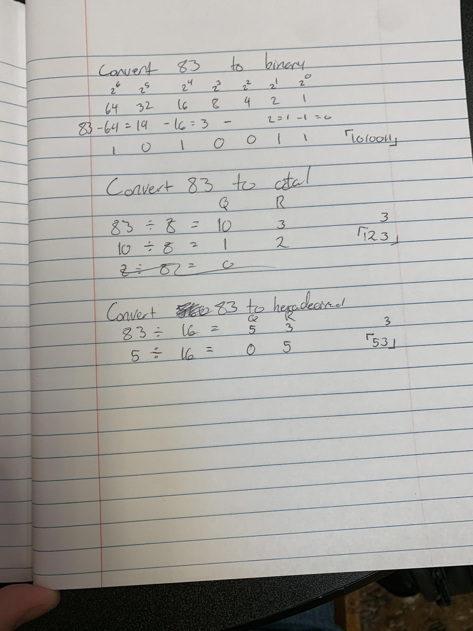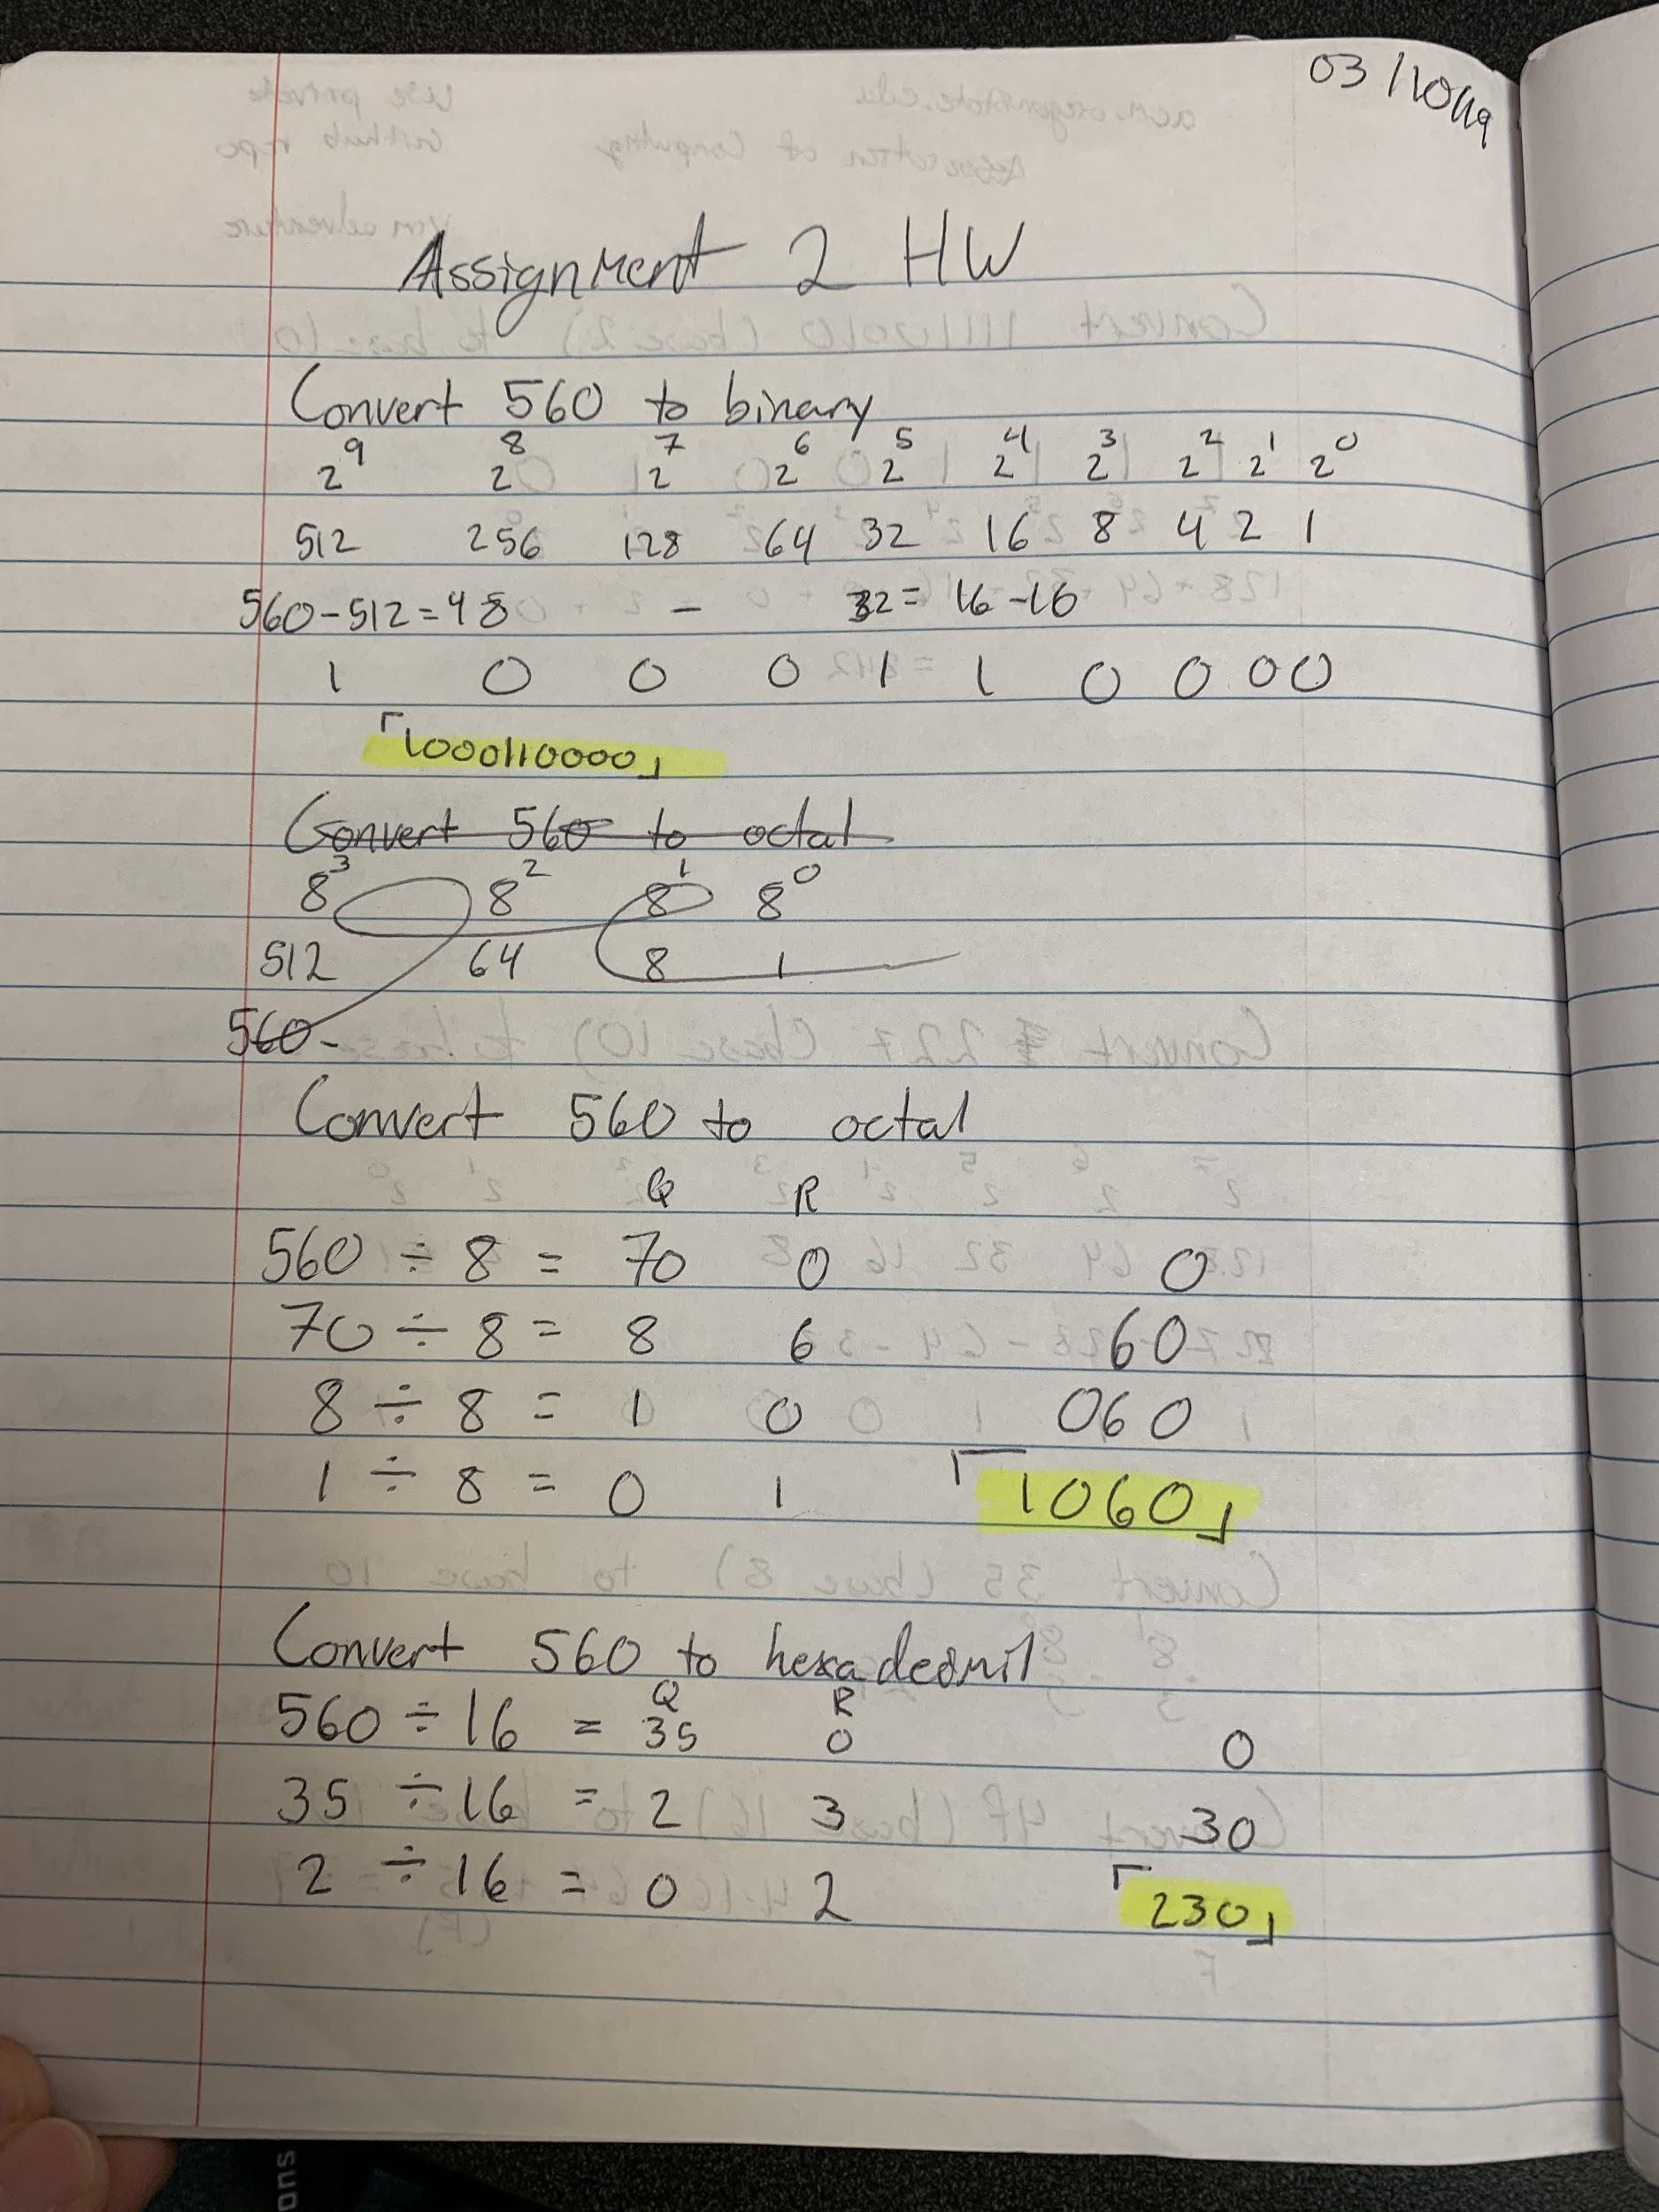

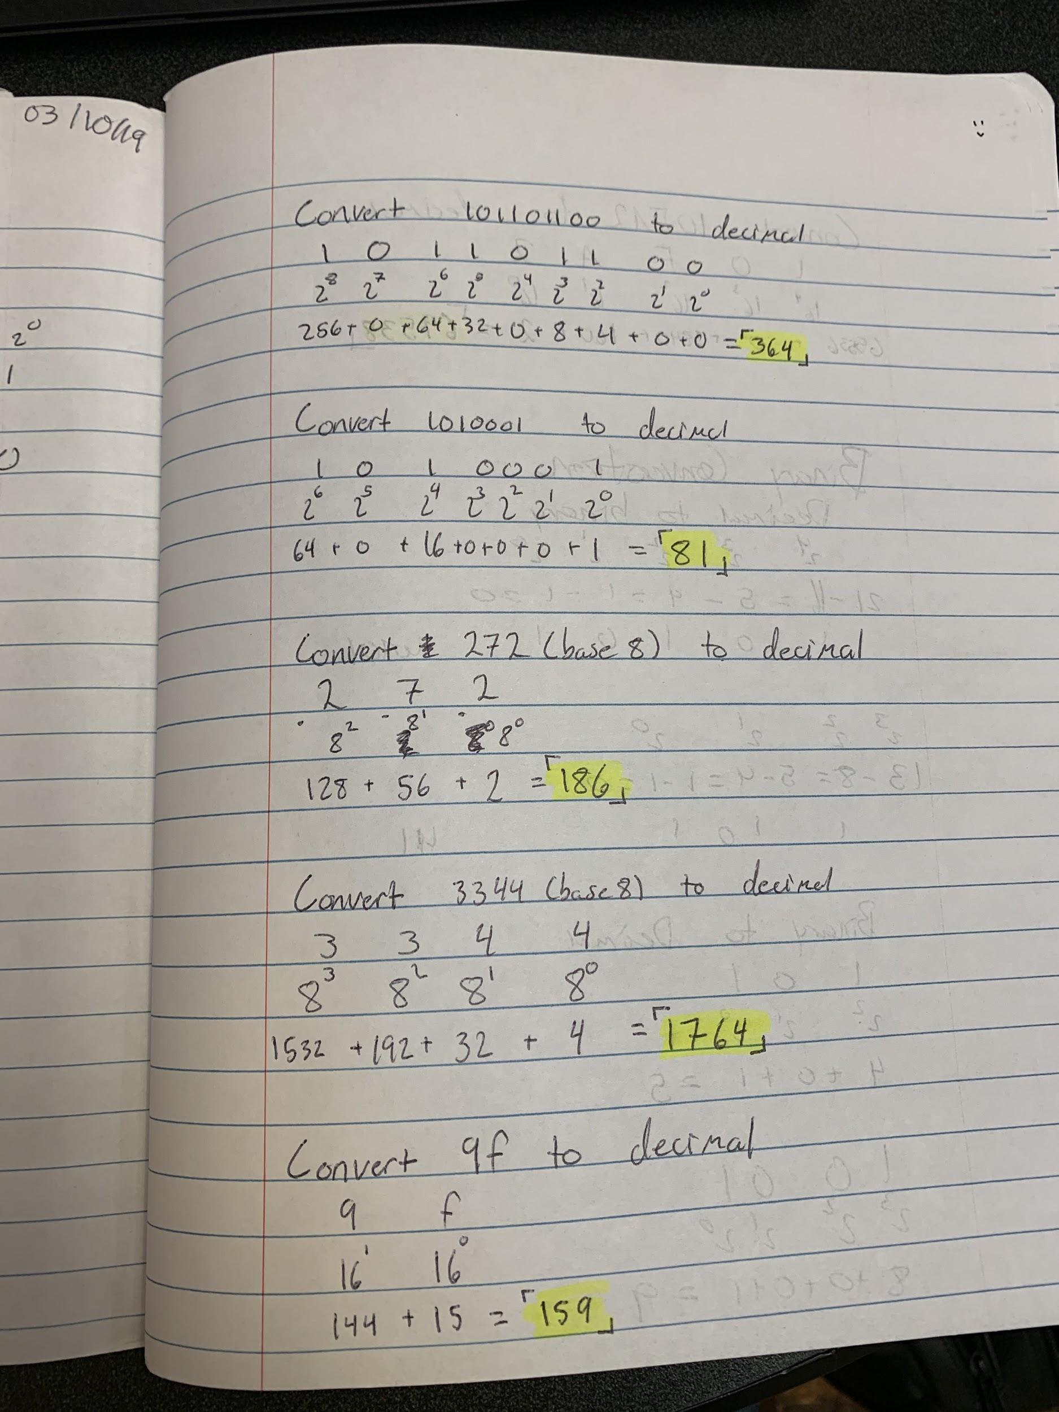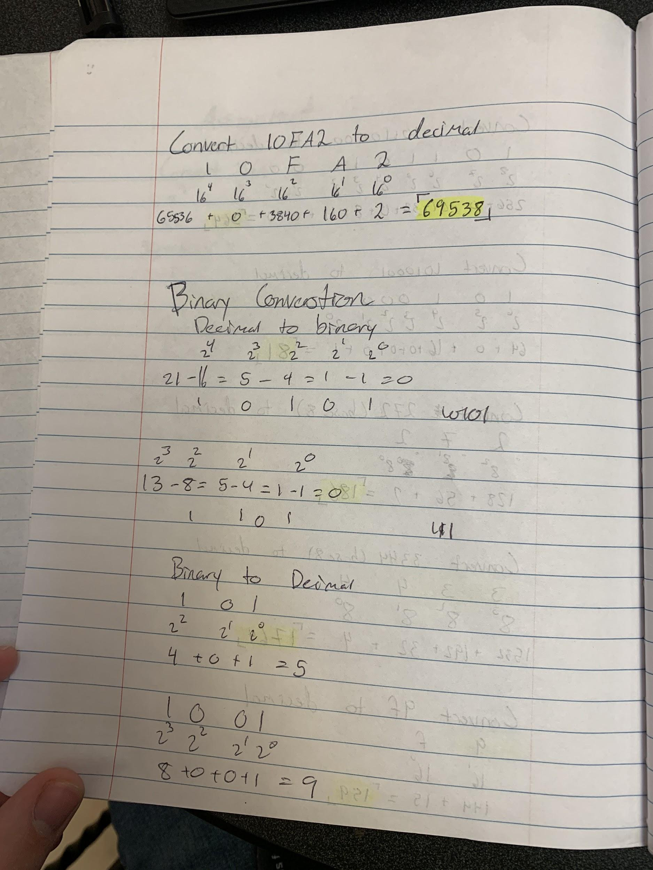

**Algorithm to convert a decimal number to binary and binary to decimal.**

*Converting Decimal to Binary*

1. Calculate the most significant bit by taking a power of two that is the least smallest number than the decimal number you are given
2. Take all powers of two below that number until 20 and write its number not expressed in a power
3. For each power if that power is able to be subtracted from the number then express a one for that bit if it is not able to be expressed than write a zero
4. Subtract that power from the number and repeat step three with your new number until you have gone through all the powers
5. The resulting 1’s and 0’s is your binary number

*Converting Binary to Decimal*

1. List all the 1’s and 0’s with the corresponding power of 2 below
2. For each 1 in the binary expression add the corresponding power of two
3. That final sum is the decimal number

**Is one way easier to explain than the other? Why?**

Converting from binary to decimal is easier to explain due to the little complexity of the conversion factors. When converting from decimal to binary there is a lot more setup and tasks which need to be explained for every step. Decimal to binary is very straightforward and does not have complex subtasks which has to be accomplished before returning to the “main loop” of the algorithm.